**Assignment 5**

**Group Members :-**

**Vishal Kesharwani**  (826)

**Dataset :** Mumbai university result

|  |
| --- |
| **Code:**  import pandas as pd  import matplotlib.pyplot as plt  df=pd.read_csv("/content/sample_data/ass4_dataset.csv") df1 = df.groupby('year_of_admission').max() plt.plot(df1.index, df1['sgpi'], marker='o')  # Customize the chart  plt.title("year of admission vs sgpi") plt.xlabel("year of admission") plt.ylabel("sgpi") # Display the chart plt.show() |

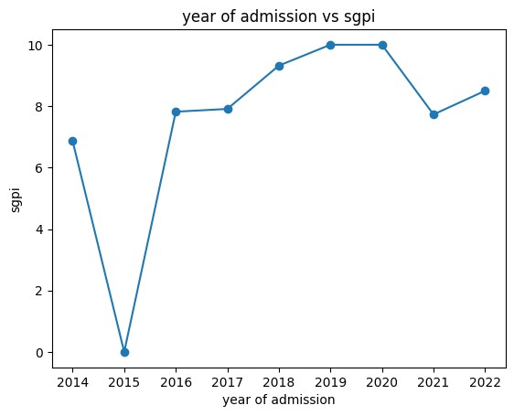

|  |
| --- |
| b=df["sgpi"]  plt.hist(b, bins=5, edgecolor='black')  # Adding labels and title plt.xlabel('sgpi')  plt.ylabel('Frequency of sgpi') plt.title('frequency of sgpi') # Displaying the histogram plt.show() |

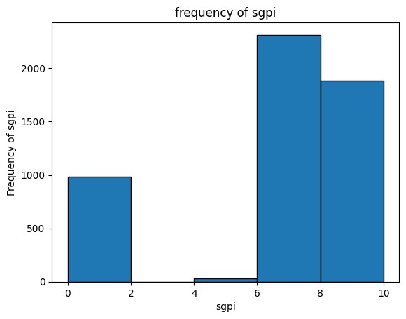

|  |
| --- |
| import matplotlib.pyplot as plt  # Example data  df1 = df.groupby('year_of_admission').max()  # Plotting the pie chart  plt.pie(df1['sgpi'],labels=df1.index, autopct='%1.1f%%') # Adding a title plt.title('sgpi% in year') # Displaying the pie chart plt.show() |

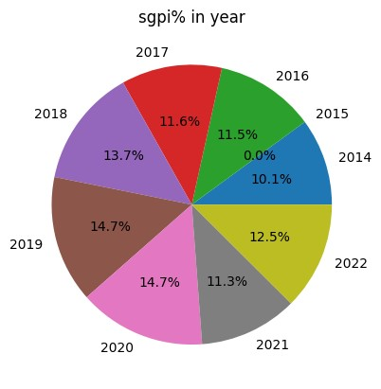

|  |
| --- |
| df1 = df.groupby('year_of_admission').max() plt.plot(df1.index, df1['status'], marker='o')  # Customize the chart plt.title("year vs status") plt.xlabel("year of admission") plt.ylabel("status of admission")  # Display the chart plt.show() |

b=df[

"status"

]

plt.hist(b, bins=

5

, edgecolor=

'black'

)

# Adding labels and title

plt.xlabel(

'status'

)

plt.ylabel(

'Frequency of status'

)

plt.title(

'frequency of student status'

)

# Displaying the histogram

plt.show()

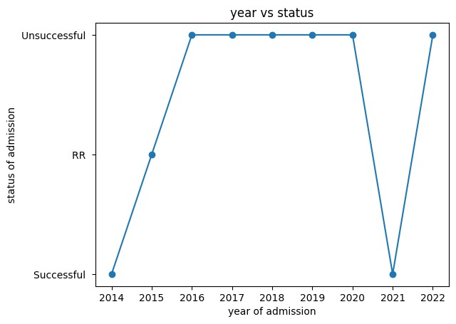

b=df[

"gender"

]

plt.hi

st(b, bins=

5

, edgecolor=

'black'

)

# Adding labels and title

plt.xlabel(

'gender'

)

plt.ylabel(

'Frequency of gender'

)

plt.title(

'Frequency of gender'

)

# Displaying the histogram

plt.show()

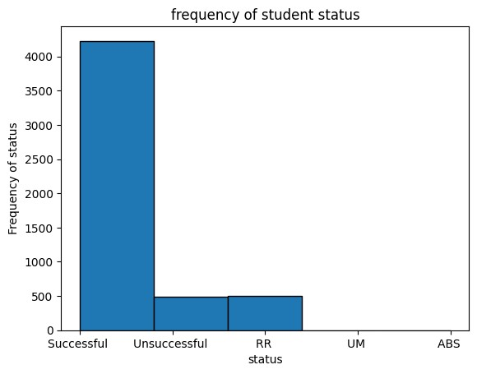

df1 = df.groupby(

'year_of_admission'

).

max

()

plt.plot(df1.index, df1[

'clg_id'

=

]

, marker

'o'

)

# Customize the chart

plt.title(

"year vs id"

)

plt.xlabel(

"year of admission"

)

plt.ylabel(

"Clg id"

)

# Display the chart

plt.show()

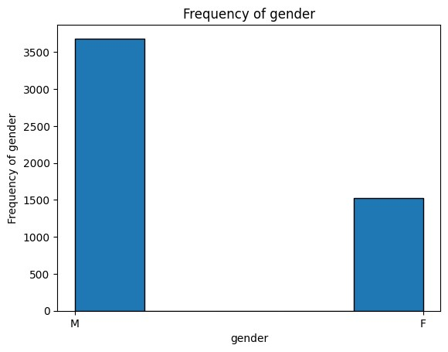

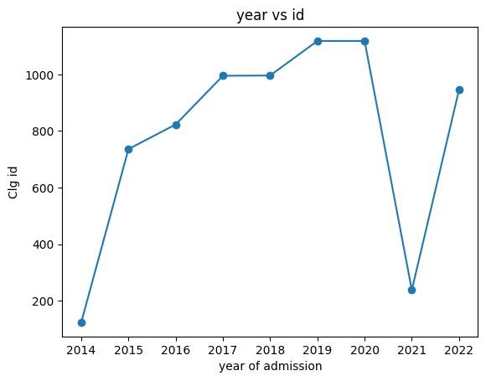

|  |
| --- |
| df1 = df.groupby('status').max() plt.bar(df1.index, df1['clg_id'])  # Customize the chart plt.title("status vs id") plt.xlabel("status") plt.ylabel("clg id") # Display the chart plt.show() |

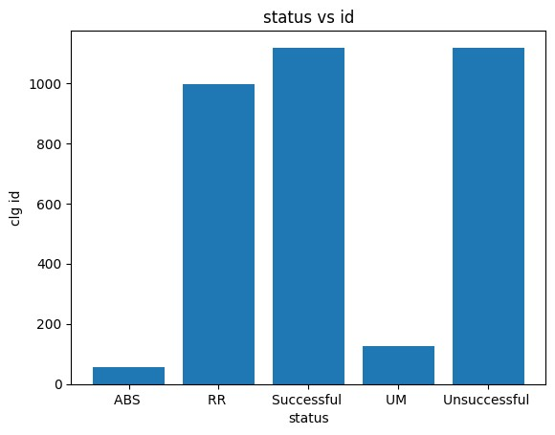

|  |
| --- |
| df1 = df.groupby('year_of_admission').max() plt.bar(df1.index, df1['total_gradepoints'])  # Customize the chart  plt.title("year vs total grade points") plt.xlabel("year of admission") plt.ylabel("total grade points")  # Display the chart plt.show() |

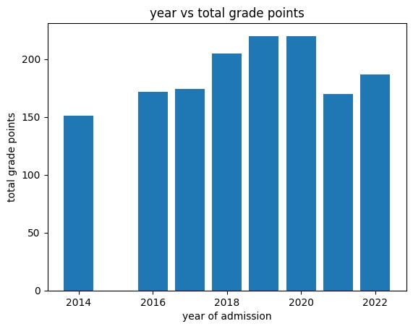

|  |
| --- |
| df1 = df.groupby('year_of_admission').max() plt.bar(df1.index, df1['clg_id'])  # Customize the plot  plt.title("clg id vs admission") plt.xlabel(" admission year") plt.ylabel("clg id") # Display the plot plt.show() |

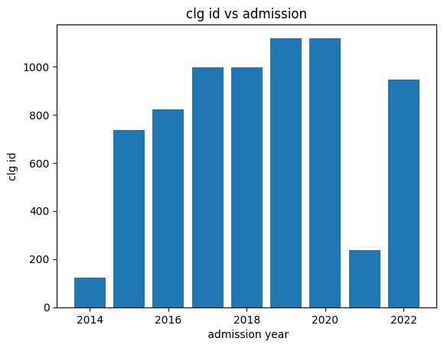

|  |
| --- |
| # Example data  df1 = df.groupby('centre').max()  # Plotting the pie chart  plt.pie(df1['sgpi'],labels=df1.index, autopct='%1.1f%%') # Adding a title  plt.title('centre and year') # Displaying the pie chart plt.show() |

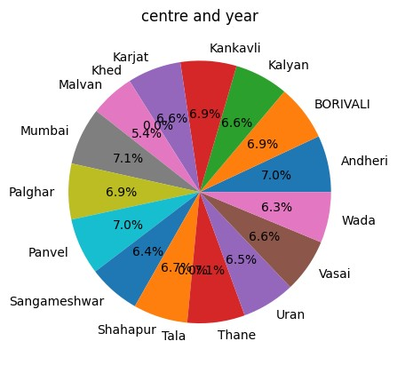

|  |
| --- |
| import matplotlib.pyplot as plt  # Example data  df1 = df.groupby('centre').max()  # Plotting the pie chart  plt.pie(df1['clg_id'],labels=df1.index, autopct='%1.1f%%')    # Adding a title  plt.title('Id and centre')    # Displaying the pie chart plt.show() |

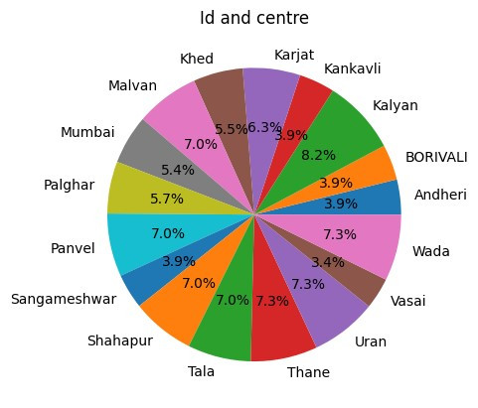

|  |
| --- |
| df1 = df.groupby('status').max()  plt.scatter(df1.index, df1['total_gradepoints'])  # Customize the chart  plt.title("scatter between status and grade point") plt.xlabel("status")  plt.ylabel("total grade point")  # Display the chart plt.show() |

df1 = df.groupby

(

'year_of_admission'

).

max

()

plt.scatter(df1.index, df1[

'total_gradepoints'

])

# Customize the chart

plt.title(

"scatter between year and grade "

)

plt.xlabel(

"year of admission"

)

plt.ylabel(

"grade points"

)

# Display the chart

plt.show()

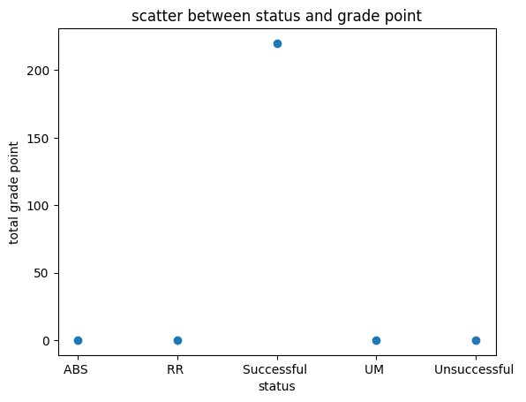

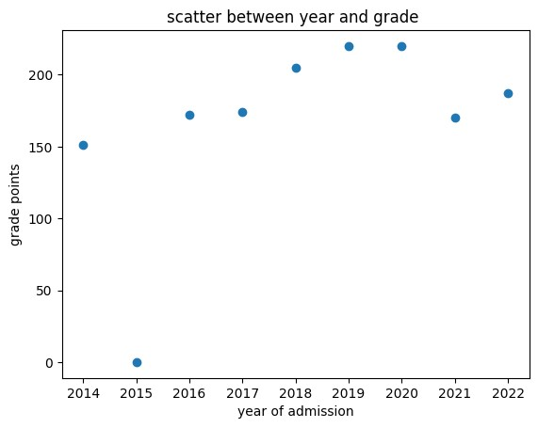

df1 = df.groupby('clg_id').max() plt.scatter(df1.index, df1['sgpi'])

# Customize the chart

plt.title("scatter between id and sgpi") plt.xlabel("clg id") plt.ylabel("sgpi") # Display the chart plt.show()

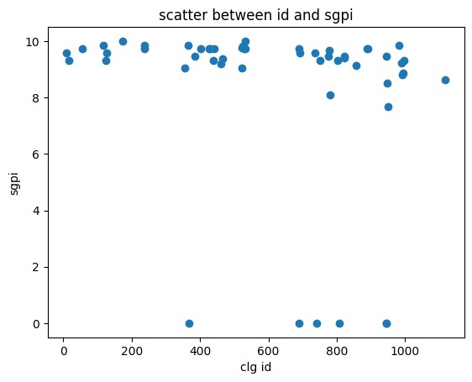

|  |
| --- |
| import plotly.graph_objects as go import plotly.subplots as sp # Create data for the panels  x =df.groupby('year_of_admission').max(); y1 = df.groupby('sgpi').max(); y2 =df.groupby('total_gradepoints'); y3 = df.groupby('clg_id').max() # Create subplots with panels  fig = sp.make_subplots(rows=1, cols=3, subplot_titles=( 'Panel '))  # Add traces to each panel  fig.add_trace(go.Scatter(x=x, y=y3, name='Trace 1'), row=1, col=3)  # Update layout and display the plot fig.update_layout(showlegend=True) fig.show() |

